NCI/CBIIT

Form Builder System

High Level Scope of changes related to GreenSheets re-design

Version 1.4

Document History

Document Location

Ensure that this document is current. Printed documents and locally copied files may become obsolete due to changes to the master document. The source of this document is located in the SVN documentation repository at: ***https://ncisvn.nci.nih.gov/svn/iscs/greensheets/Requirements/Specs/***[Form Builder - Scope of changes.docx](https://ncisvn.nci.nih.gov/svn/iscs/greensheets/Requirements/Specs/GreenSheets%20-%20Scope.docx)

Revision History

[Provide a summary of changes for a new version or revision of this document.]

| Version Number | Revision Date | Author | | Summary of Changes |
| --- | --- | --- | --- | --- |
| 1.0 | 09/12/2016 | G. Tulchinskaya | Initial version | |
| 1.1 | 09/20/2016 | G. Tulchinskaya | Updated reporting requirements | |
| 1.2 | 10/25/2016 | G. Tulchinskaya | Updated sec. “User-friendly interface for active hyperlinks” after OGA input (approach change). | |
| 1.3 | 11/22/2016 | G. Tulchinskaya | Added section Non-Functional Requirements => “Field lengths” | |
| 1.4 | 12/08/2016 | G. Tulchinskaya | Added sec. “Additional Requirements”. No changes in FB are needed, just capturing existing requirements. | |

Reference Documents

[Provide a complete list of all documents referenced within, or in the formulation of this document.]

| Document Name |
| --- |
| <https://ncisvn.nci.nih.gov/svn/iscs/greensheets/Requirements/Specs/GreenSheets%20Redesign%20Project%20Scope.docx> |
|  |

Key Terms

Please refer to <https://ncisvn.nci.nih.gov/svn/iscs/greensheets/Requirements/Specs/GreenSheets%20Redesign%20Project%20Scope.docx>

[This information may be provided by reference to the eRA Global Glossary (or the project- or system-specific glossary), and in such cases, simply reference those documents and leave the table below blank.]

Table of Contents

1. Document scope 3

2. Creation of the Revision form in FB and promotion of the Revision module 3

3. Reporting 6

4. User-friendly interface for active hyperlinks 7

Process of creating and editing a question in Form Builder 8

Additional requirement: 11

Changes needed in the Form Builder (step by step) 11

5. Additional Requirements 16

6. Help system 16

7. Non-Functional Requirements 17

7.1 Field lengths 17

7.1.1 Question level 17

7.1.2 Form Level 19

7.1.3 Section Level 20

7.1.4 Module Level 21

7.1.5 Category Level (related to TypeMech passed to GS) 21

8. Issues 22

# Document scope

[Outline the scope of what has been captured in this version of the document. For example, “This Supplementary Specification document describes the functional and non-functional requirements that span Use cases for the ABC system, Release 4”.]

This document provides high level overview, dependencies and outlines current and possible future functional and non-functional requirements of the Form Builder System, related to GreenSheets re-design project

# Creation of the Revision form in FB and promotion of the Revision module

GSFB - 122

Ultimately, completed greensheet forms are needed for award of the grant. In reality, grant can be awarded only via ‘actions’ in GPMATS.

GPMATS actions can be of two types: AWARD or REVISION; during GreenSheets re-design project, OGA indicated the need to have a separate form (template), related to REVISION type of the action in GPMATS.

To accommodate this need, FB and GreenSheets systems should be modified as follow (high level):

* User will create a new module in FB (user can call it “Revision module”, but this is “as-is” functionality, no changes)
* User will create a form (user can call it “Revision form”, but this is “as-is” functionality, no changes)
* Change => FB should add CATEGORY Type (AWARD and REVISION)

|  |  |
| --- | --- |
| Category type | Related FB forms |
| AWARD | Program and Specialist forms are needed |
| REVISION | * Only one revision form is needed for all type/mechs * Revision form will be used by Specialist only |

* User will add Revision form to Revision module (no changes)
* Change => User will export/deploy the Revision module; the name of the module will be the same as in GreenSheets in order to export/promote this module

Details for changes to create a category process

The system will allow to select ALL types and mechanisms while creating a category.

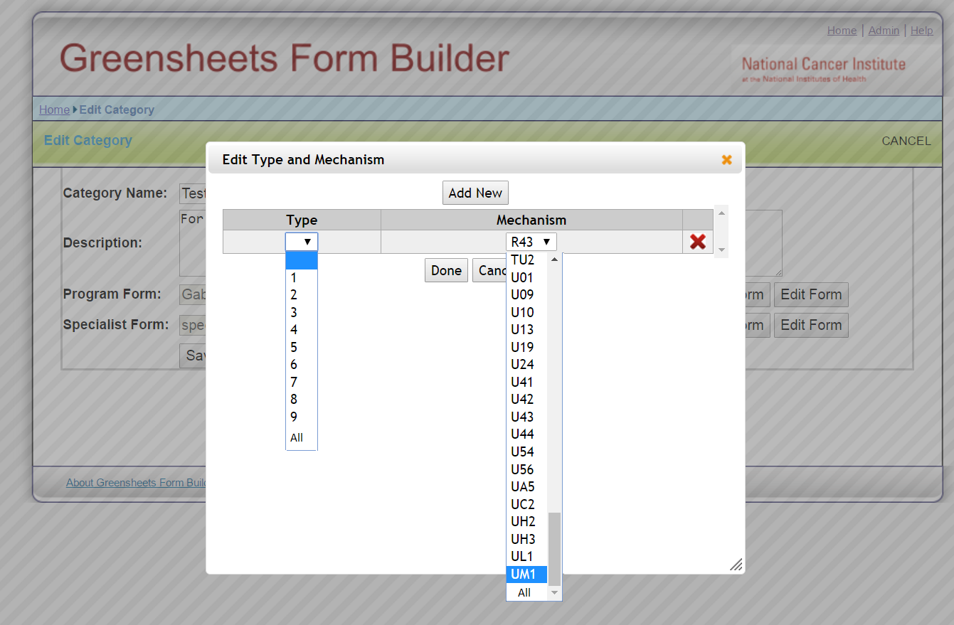

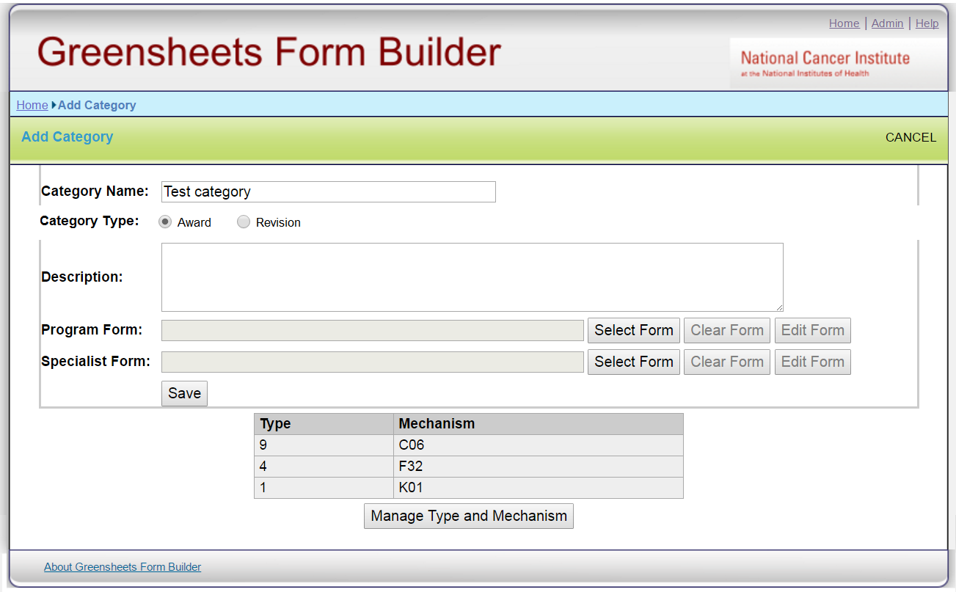

When OGA user adds a category, s/he may choose a category type (Award or Revision)

On the screen category type will be defaulted to ‘Award’ (OGA mentioned that after Revision form is created and deployed, it will never change).

* If ‘Award’ type is chosen, the process is as usual
* If “Revision” type is chosen:
  + The screen will allow adding only Revision form
  + User will select ALL types/mechanisms (no validation for ALL/ALL combination, it will be responsibility of the user, it will allow more flexibility in the future)

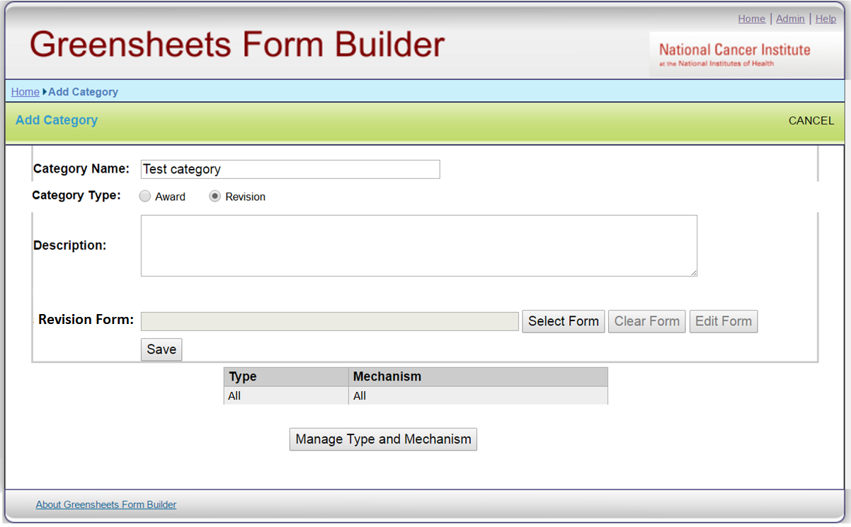

**C**ategory type will become read-only when editing existing category.

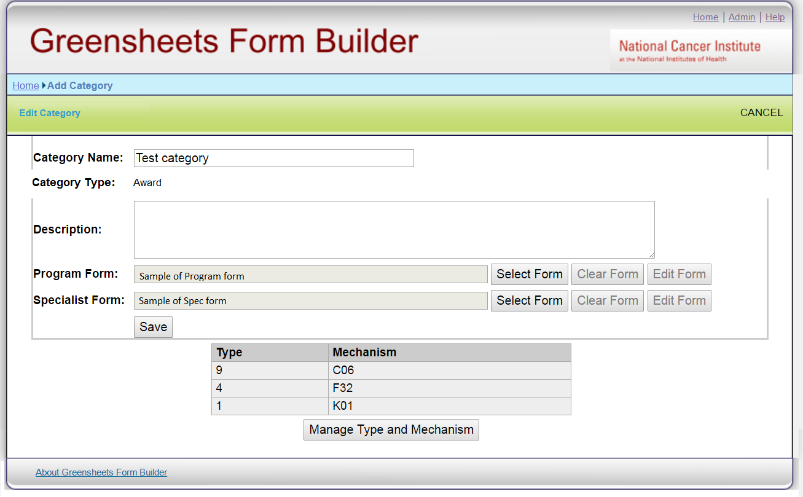

# Reporting

GSFB-125

Requirements provided by OGA:

“When a question is modified in Form Builder it is not easy now to find out what it will affect. It would be nice to have a report which displays the following elements:

a.            Question text

b.            Question id (since the same question cannot be used in sections of the same form they end up creating tons of “Please Explain” or “Additional Comments”, it is a pain point finding these particular questions for future re-use. Maybe we need to take a look at the reason why the same Comments box cannot be used in several sections of the same form in FB)

c.             Created date of the question

d.            Creator user id

e.            Last_upd_date

f.             Last_upd_id

g.            Section name

h.            Section ID

i.            Form name

j.             Form ID

k.           Type/Mech combination

l.            Module Name

m.          Module ID.

Additional requirement for the report:

1. The report is needed in Excel format
2. Users of the report: Sean, Shane and Crystal (all OGA staff), and maybe some people from OGA Operations team. Any user with access to Form Builder should be able to access this report. No special role is needed.
3. Link to the new report needs to be placed on Home page green banner, to the right of History link. It can be named "Report"

Note: There is a desire to get a group of users together (Sean, Shane, Crystal, Stacey, Eugenia, Rob Jones, Kevin Johnson), possibly with CBIIT representatives at the beginning of October 2016 to define the SOPs for creating questions and making edits to them. OGA users want to understand the downstream effect of these modifications and put together a guidance for OGA on creating clean data. Clean up of the existing data may become part of this group discussion.”

# User-friendly interface for active hyperlinks

GSFB-124

* Form Builder will embed WYSIWYG editor instead of enterable field for “Learn More” (in all 3 places: questions library, sections library, form). Something like at <http://jwysiwyg.github.io/jwysiwyg/help/examples/01-basic.html>

From this:

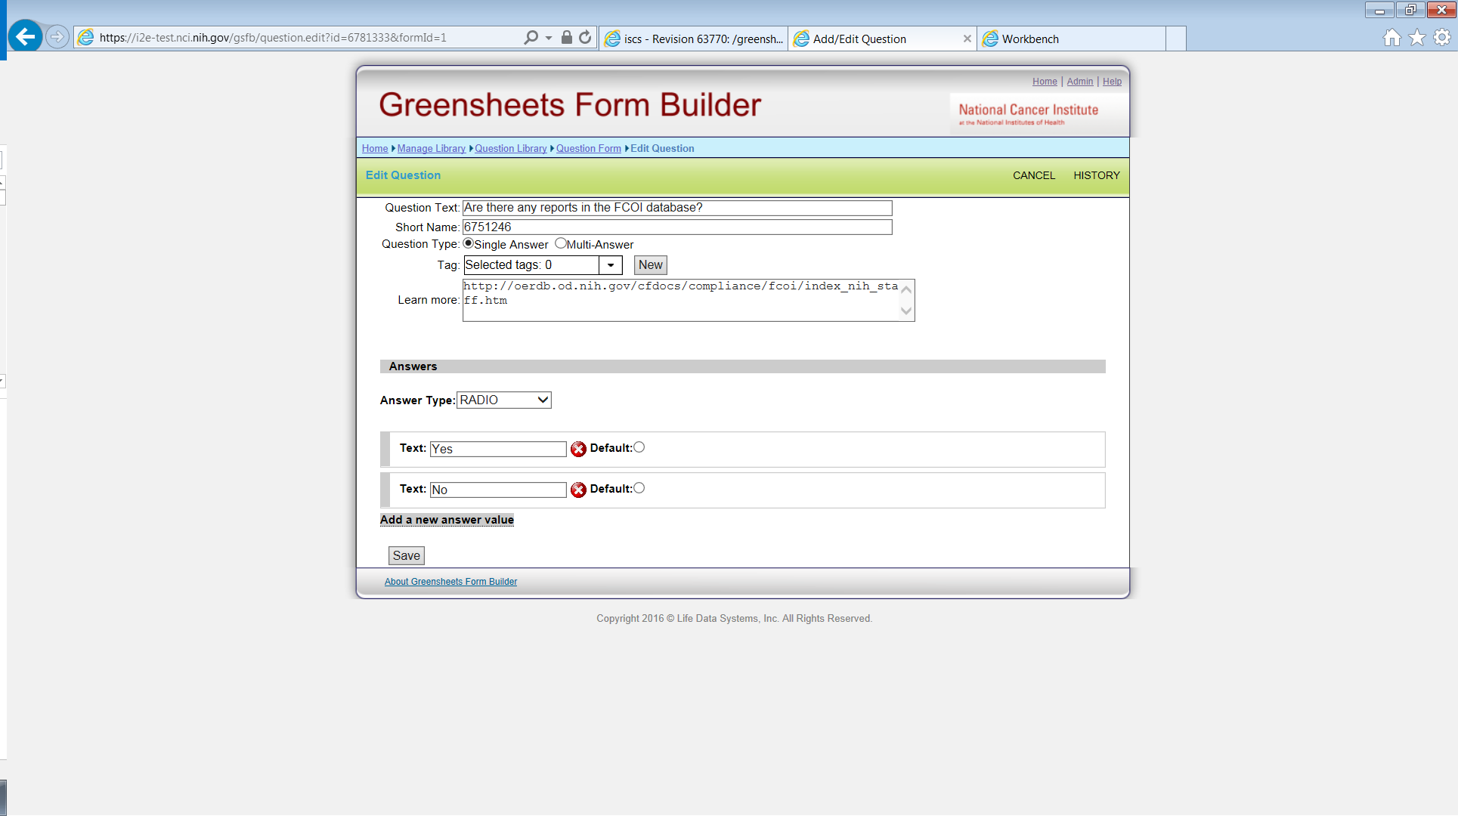

To this: 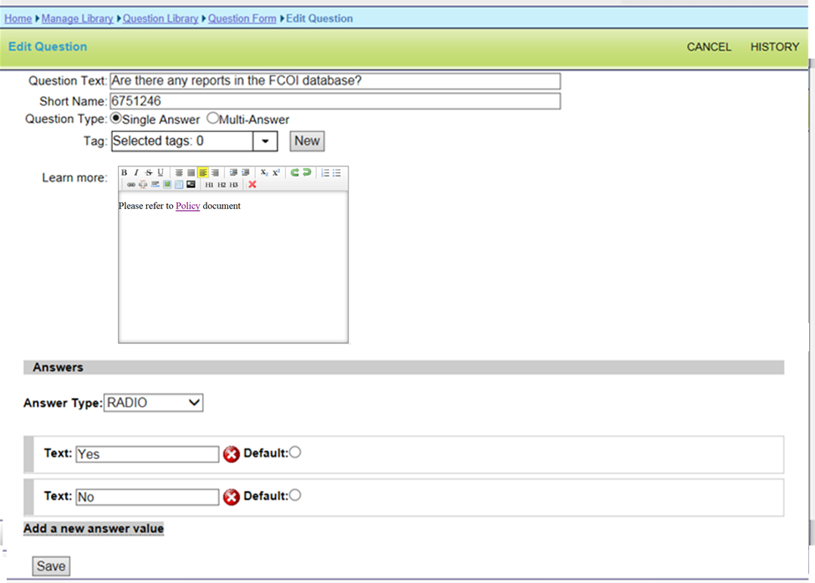

The buttons on the ribbon of the tool can be filtered based on the following:

A-must are: Bold, Italics, Underline, Undo, Create Link, Remove link and Remove formatting.   
Nice to have are: Indent, Outdent, Numbers and Bullets, Horizontal rule and Header 1, 2, 3.  
Not needed: Superscript, Subscript, Insert picture, Insert table, Insert Code Snippet.

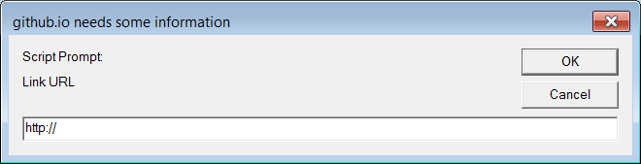

* A new report (see this document, sec. “Reporting”) should be readily accessible to a user working on a question in SECTIONS and/or QUESTIONS library

# Process of creating and editing a question in Form Builder

Question consists of the two types of elements:

* Elements that define the meaning of the question (we will call it “Level 1 elements”). If changed, the whole meaning of the question might change. According to Crystal, such elements must be changed only on the level of QUESTIONS library. These are all element on the screenshot below except ‘Learn more’ field (this will be changed with re-design, moving “Learn more’ field to Level 1).

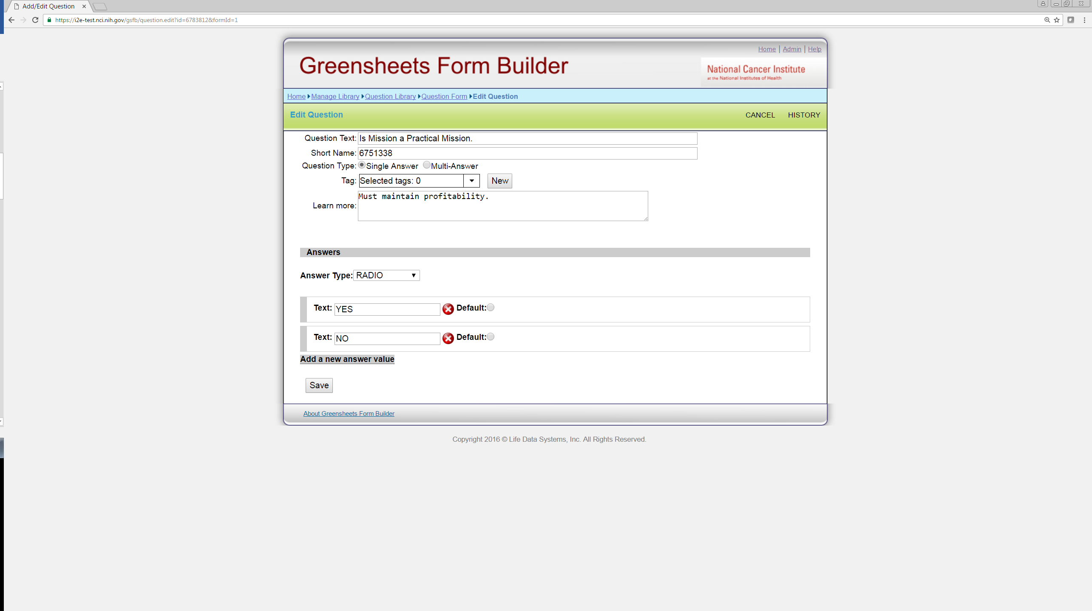

* Elements that don’t change meaning of the question, they can be refined at the level of SECTION or even on the form (we will call it “Level 2 elements”). Currently, “Learn more” field belongs to this level of elements (will be moved to Level 1).

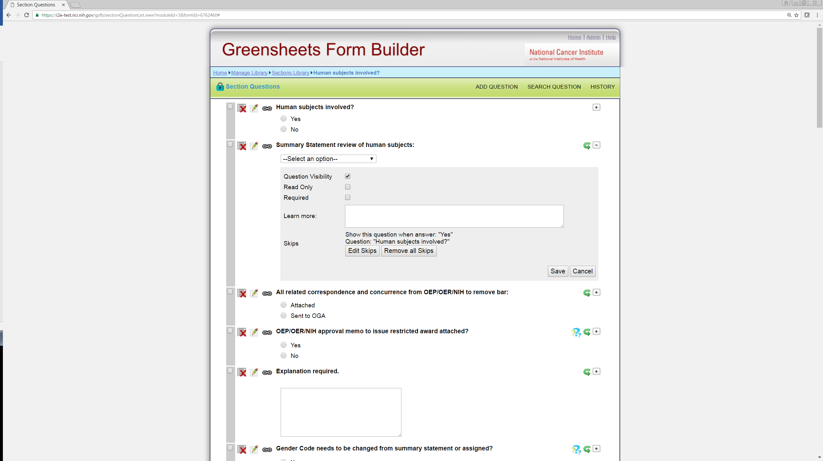

Figure 1: Needed workflow



New major requirement: “Learn more” field should belong to “Level 1 elements”.

When user adds/edits question in Question library/Section library/Form (in the library of individual), changes to “Learn more” field must be propagated to the Question library, affecting all sections/forms where this question is used. Additionally, OGA requested ‘linkage’ information, similar to information already available on the question library list, right on the Edit Question screen. Something like this (specific UI can be proposed later).

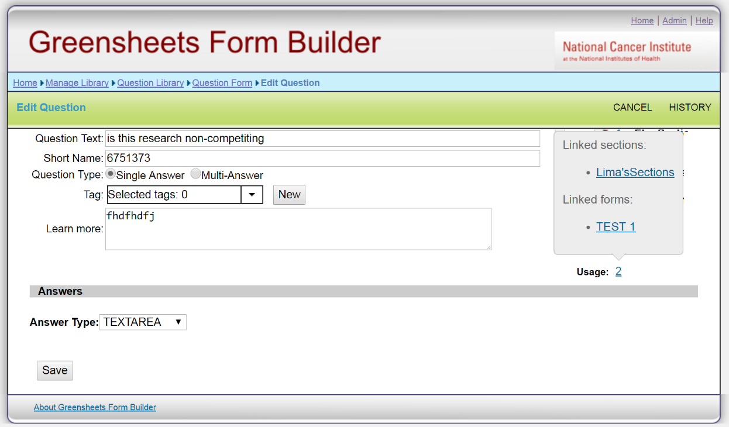

“Learn more” field should be deleted from the portion (on form and section level) that appears on cid:image006.jpg@01D2247E.A77C5BF0 (expand).

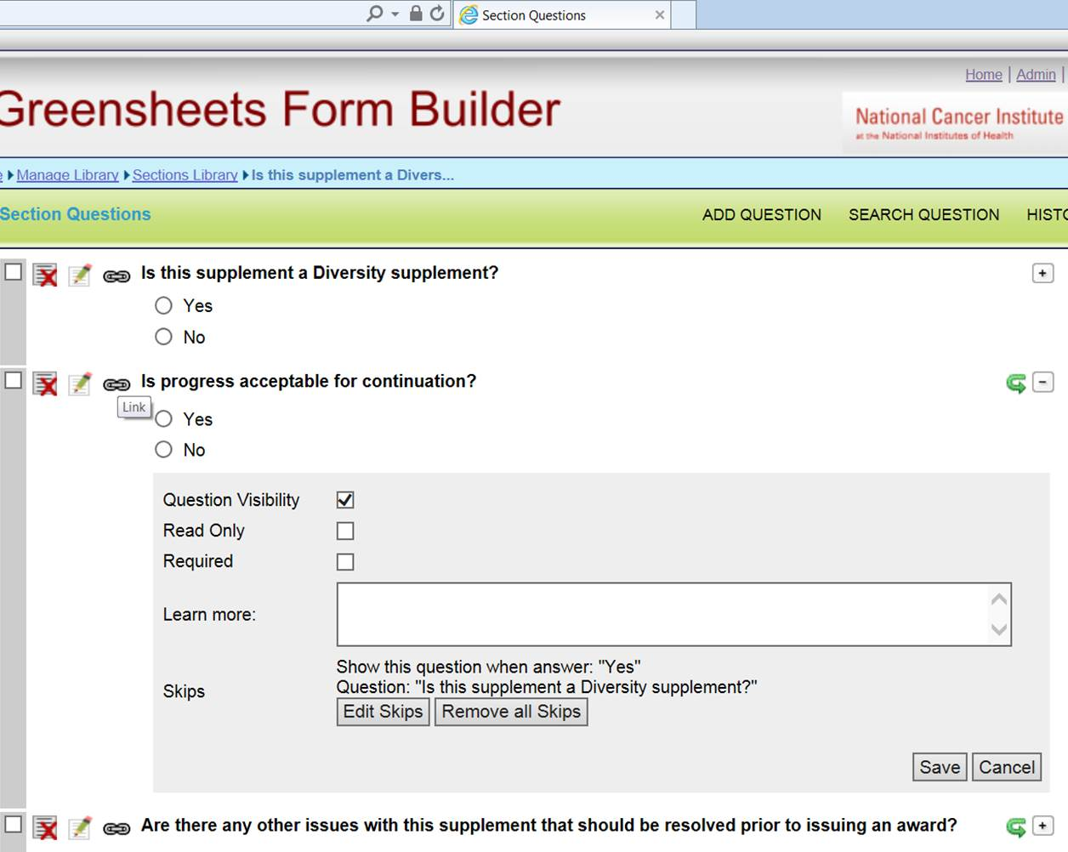

Additional requirement:

Since now all questions will be in the QUESTION library, at the moment we will go into production, we need a script to pick up all ‘orphan’ questions on the form(s) that are not in the QUESTION library and add them to the QUESTION library

Changes needed in the Form Builder (step by step):

1. **In the Question library**:

When user adds/edits question in Question library, changes to “Learn more” field will affect all sections/forms where this question is used. Additionally, OGA requested “linkage” information right on the edit question screen. Something like this (specific UI can be proposed later).

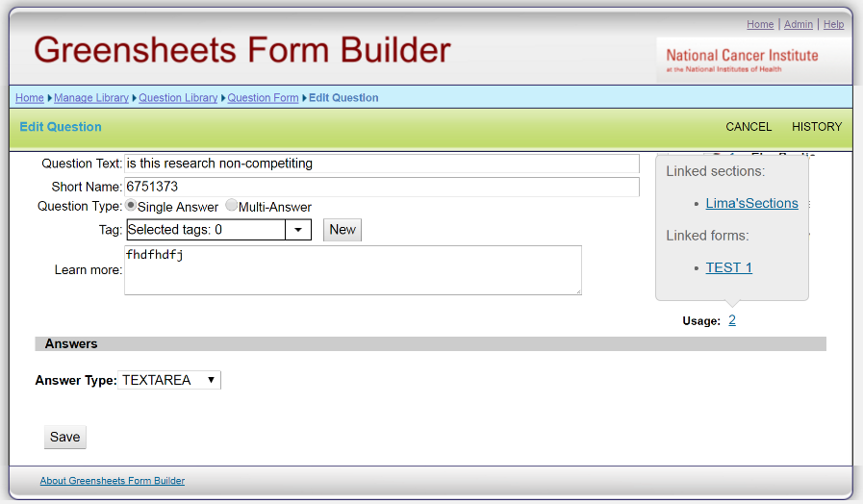

1. **In the SECTIONS library**:
   1. When “Add Question” functionality is used, this new question should be automatically saved to QUESTION library. In turn, it will affect all forms where this section is used. There is no need to display cid:image005.jpg@01D2247E.A77C5BF0 (“Link”) icon



* 1. Keep  ability to modify Level 1 elements of the question (elements that define the meaning of the question, including Learn more field). When user edits question in Section library, changes to Level 1 elements must be propagated to the Question library level, affecting all sections/forms where this question is used.

Currently, if a user clicks near the question in the SECTION library, it leads to the screen below. This screen needs to have “linkage” information

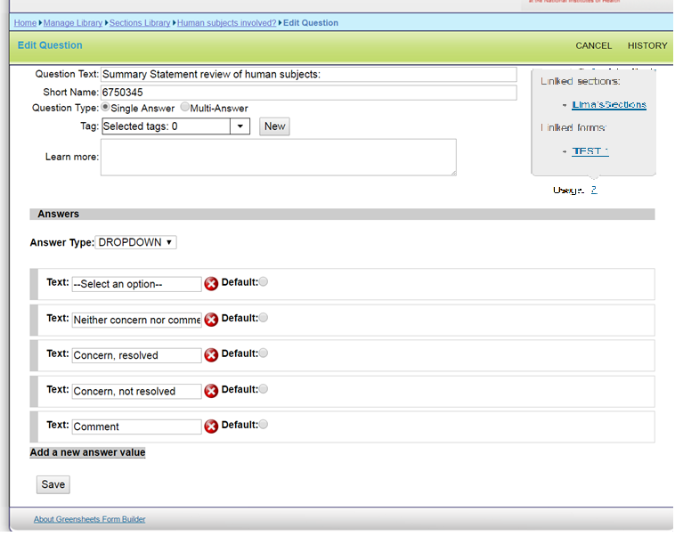

* 1. Functionality on => when user clicks this icon, the system opens the part of the screen that allows to modify Level 2 elements (that don’t change meaning of the question):
     1. Delete ‘learn more’ field
     2. If user edits Level 2 elements, this change is propagated to all forms related to this section, but is NOT propagated back to QUESTIONS library. The system already works this way.



1. **On the FORM level:**
   1. Keep “Add Element => Add Question” functionality. When “Add Question” functionality is used, this new question should be **automatically** added to the QUESTION library. Thus the 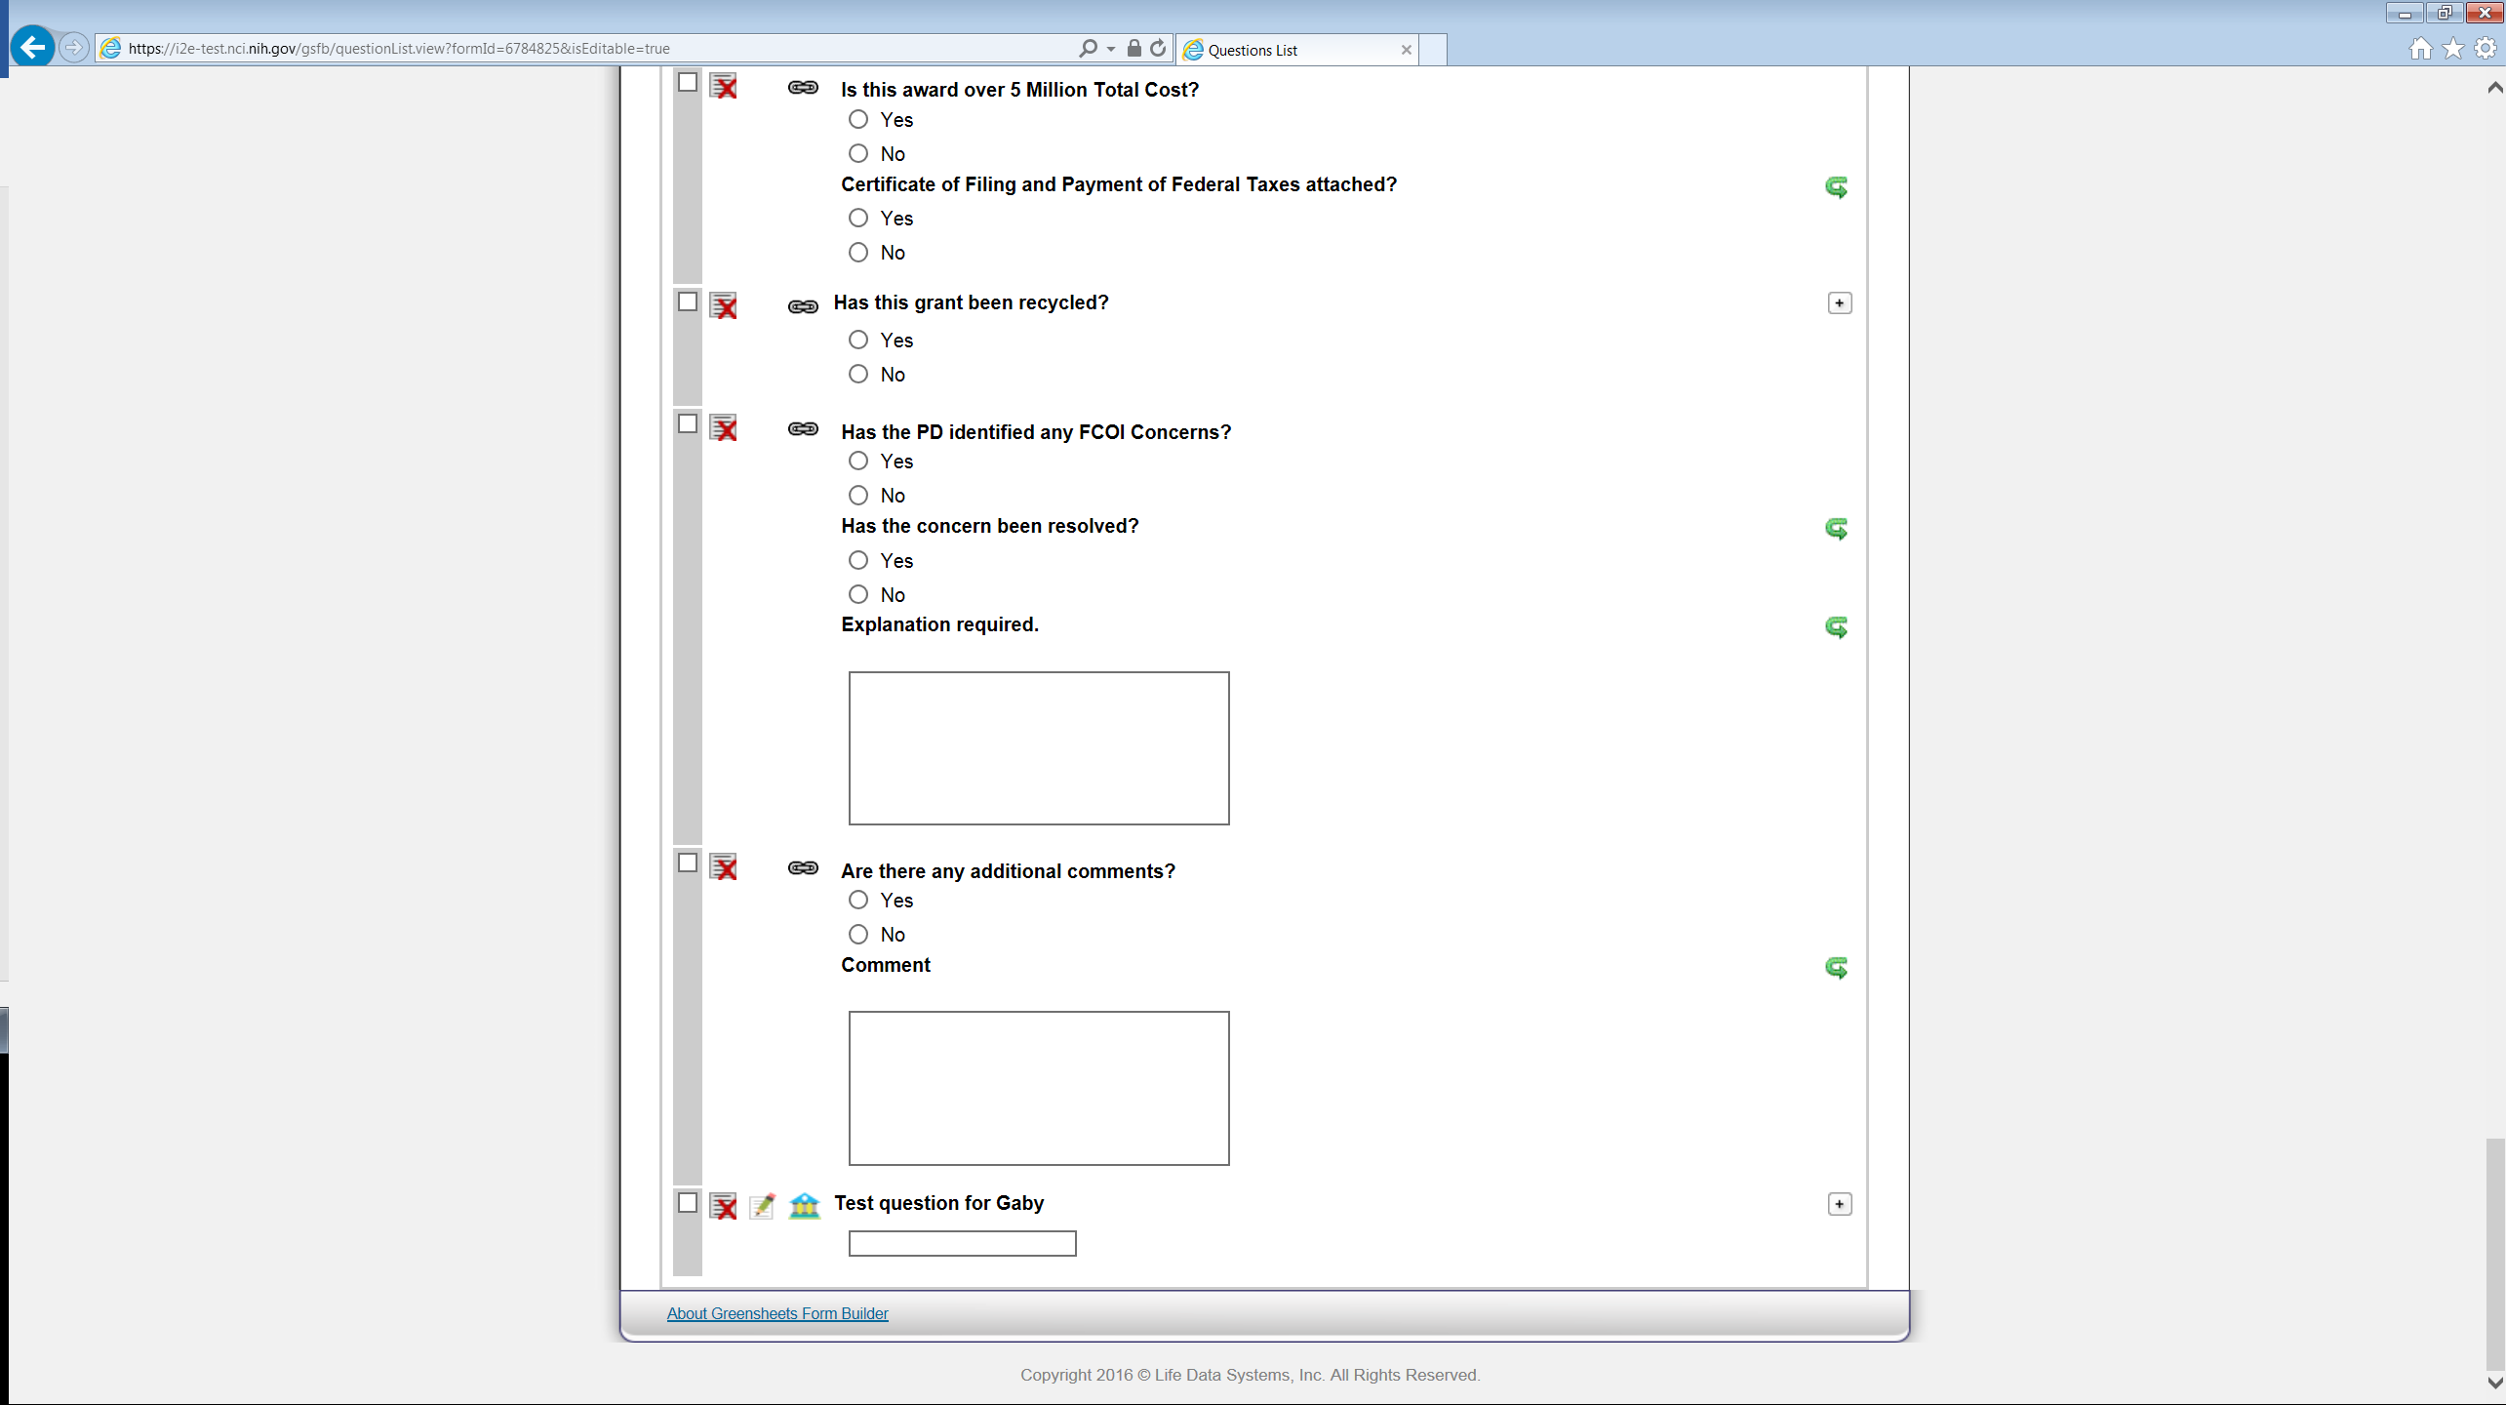”Add to library” icon should not be displayed.

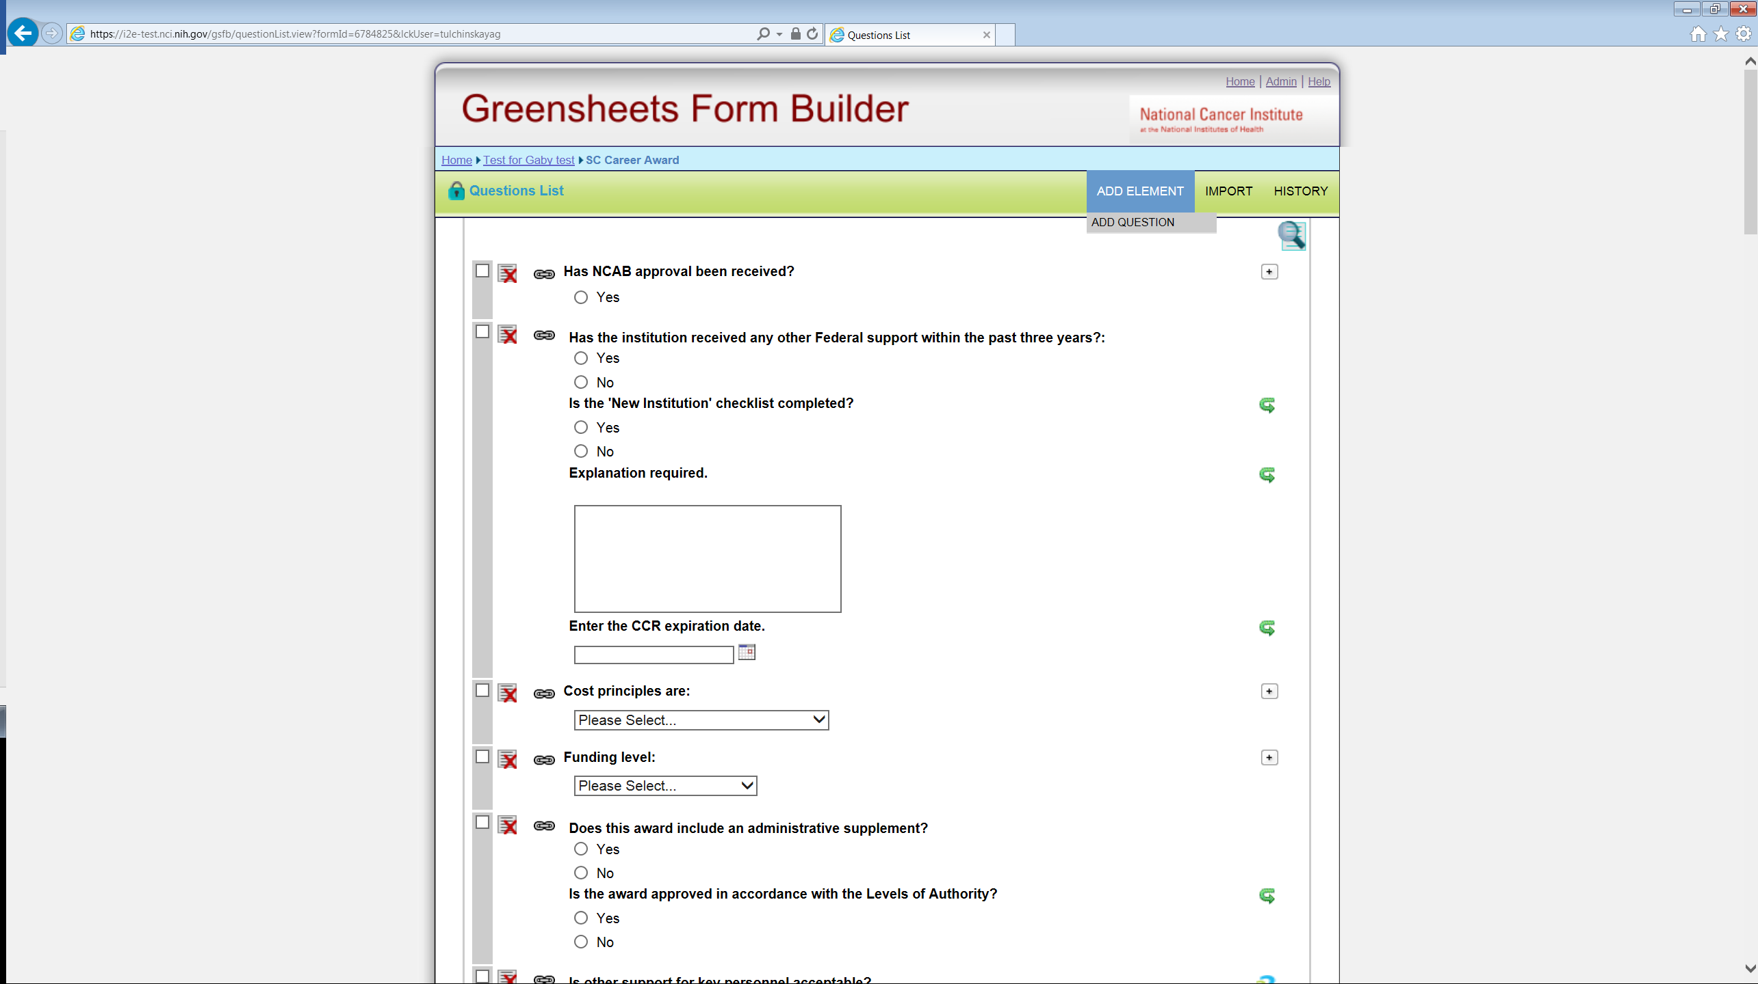



Since every question is always in the Question library, there is no need to display cid:image005.jpg@01D2247E.A77C5BF0 icon (“Click to break this link”), it just clatters the screen

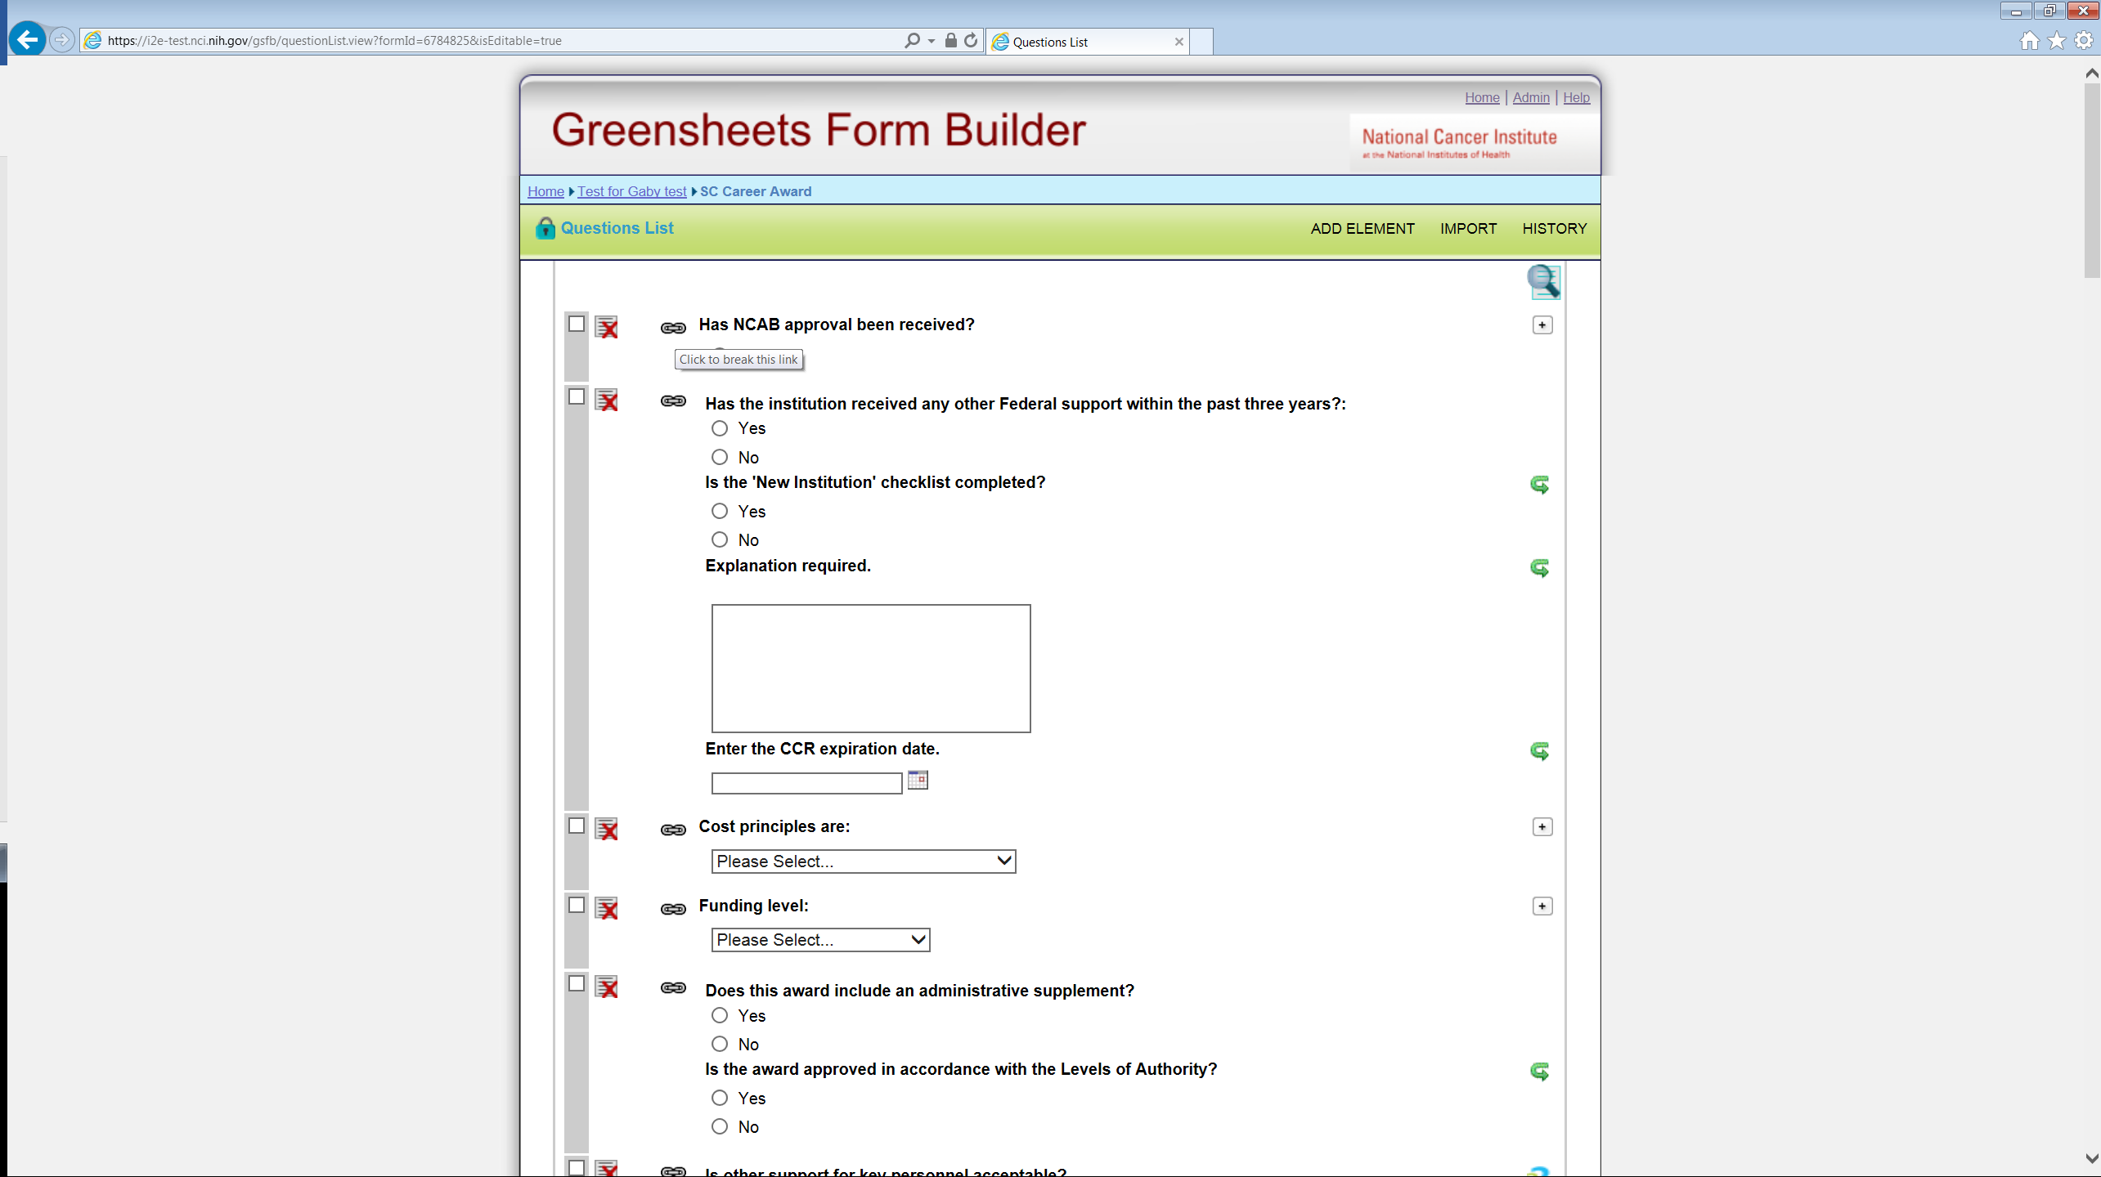

Basically, only “Delete” and “Edit” icon will be displayed for a question that is NOT in the section. If user edits the question that is not in the section, edits to Level 1 elements are propagated to the QUESTION library and affect all other sections and forms where this question is used.



Currently, if a user clicks near the question that is NOT in the SECTION, it leads to the screen below. This screen needs to:

* Have “linkage” information
* All the changes will be saved on Question library level, thus affecting all the sections and forms where the question is already linked



* 1. Functionality on => when user clicks this icon, the system opens the part of the screen that allows to modify Level 2 elements (that don’t change meaning of the question):
     1. Delete ‘learn more’ field
     2. If user edits Level 2 elements on the form for a question that is NOT in the section, this change will stay on the form only

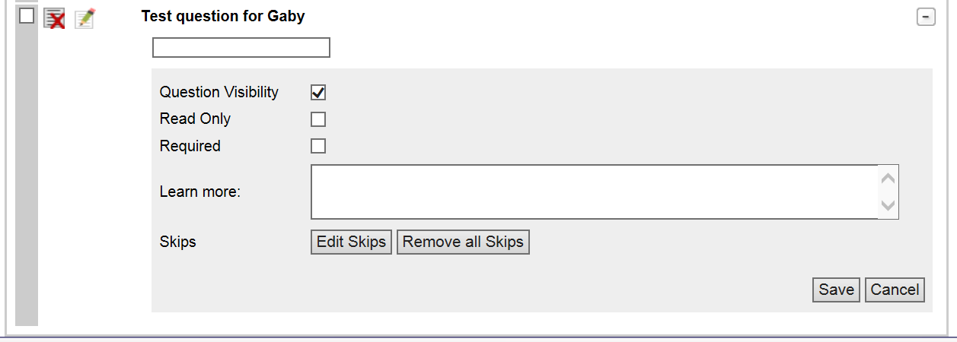

1. When questions ARE in the section, they cannot be edited separately (current functionality). Keep ability to break the section into separate questions.

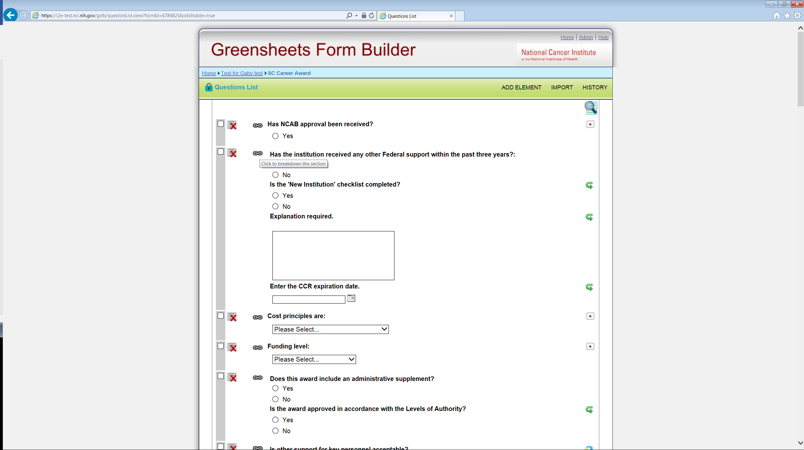

1. Ability to navigate directly from the section in the form to this section in the SECTION library is needed. OGA proposed to add an icon on the section level in the form (some **variation** of edit link that will lead to this section in the Section library, where questions can be edited without breaking the section)

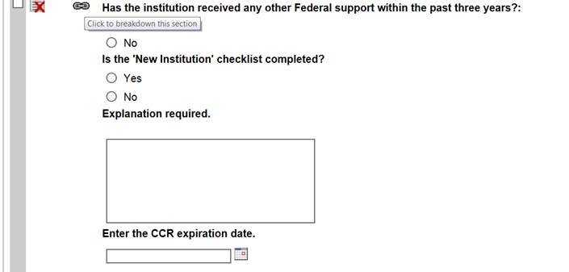

Figure : Insert link to the Section library

Functionality change is NOT needed for:

* Search in Form Builder (currently “learn more” field is not searchable; we can keep it as-is)
* Usage information when user clicks on the number next to the question in the SECTIONS library and in the QUESTIONS library; keep as-is
* Existing business rules related to an approval process that allow or not editing a question can be kept as-is

# Additional Requirements

1. The system should allow to add a question that has an answer type Radio Button (or sometimes checkbox), but only one option of the answer (e.g. Yes). Form(s), containing such questions can be exported into Greensheets. *From OGA on 12/08/2016 (from Sean and Eugenia): “The short answer – yes, this would be legitimate where the only option is yes (i.e. either you did or you need to ☺). “*

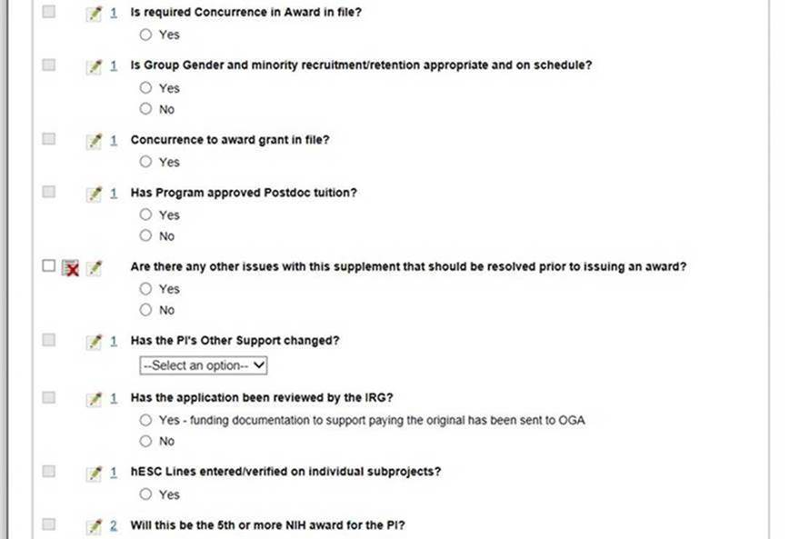

# Help system

See GSFB-123

Existing FB user guide should be updated to reflect all functionality changes in this document.

# Non-Functional Requirements

Please refer to

|  |  |  |
| --- | --- | --- |
| # | Ticket # | Ticket title |
| 1 | [GREENSHEET-507](https://tracker.nci.nih.gov/browse/GREENSHEET-507) | For GSFB: allow to export XML into the local computer |
| 2 | GREENSHEET-514 | [SCOPE] - New Greensheets should have NO defaults |
|  |  |  |
|  |  |  |

## Field lengths

Related to GSFB-128 - [Add length limits to the string elements of module and form XSD schemas](https://tracker.nci.nih.gov/browse/GSFB-128)

Field lengths should be limited in FB and GS.

1. When user attempts to enter more that allowed number of characters in FB, the system should provide an error message (we need it in case when user attempts to copy/paste, e.g in Learn More field)
2. FB should have a log. When FB cannot pass XML due to a field length failure, the meaningful record should exist in the log file for troubleshooting purposes

NOTE: log messages should include exact pointer to the module/form/question and, possibly, some additional information, deemed necessary by development team.

### Question level

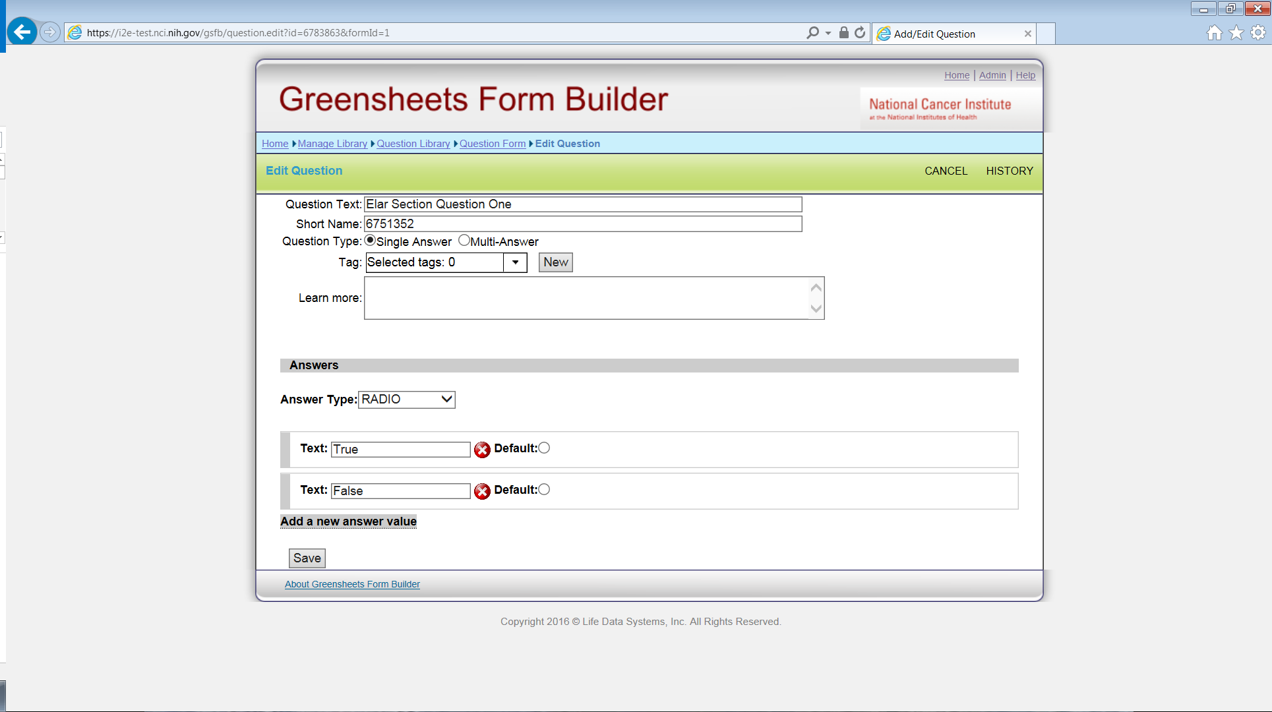

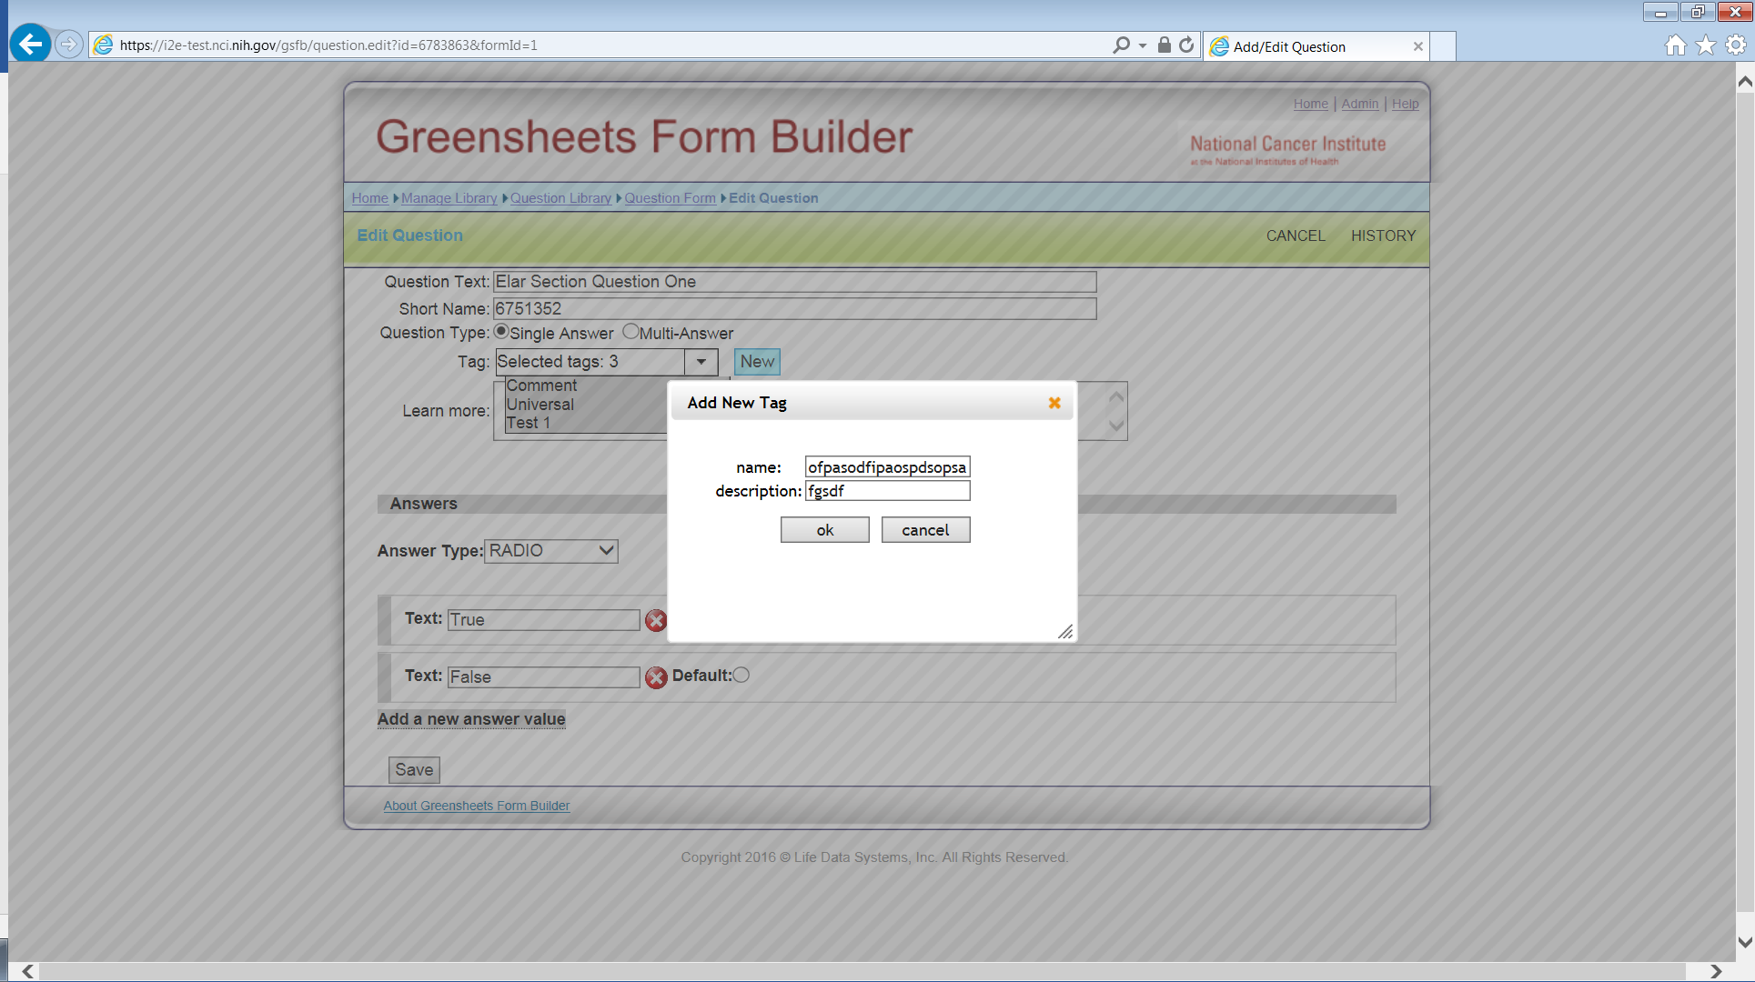

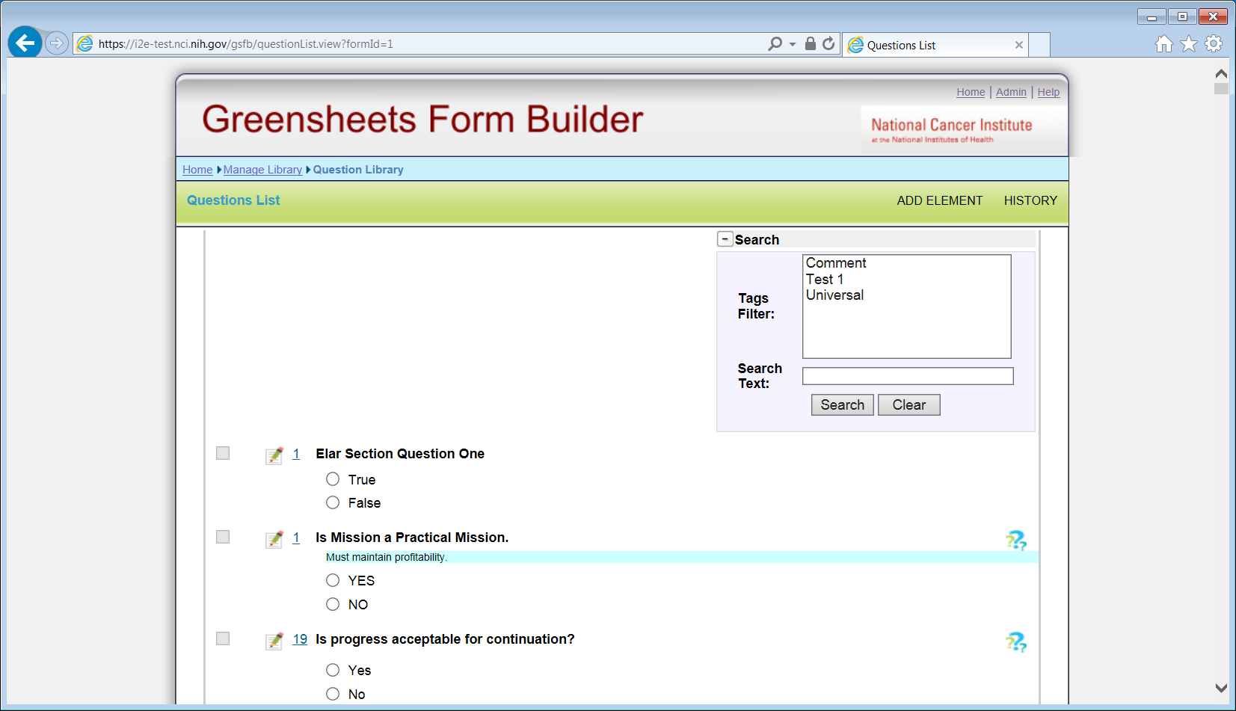

|  |  |  |  |  |
| --- | --- | --- | --- | --- |
| Field name | Length | Message for FB UI | Message in FB log | Comment |
| Question text | 2,000 | Question text is longer than allowed | Invalid length of question text | Since international characters can take up to 4 bytes (and the max limit of bytes for Oracle is 4000) so you can type up to 1000 international characters.  In a real life, I think we will never hit this limit. You will be able to use up to 500 international characters in the field limited by VARCHAR2(2000) |
| Tag Name | 50 | Tag name cannot be longer than 50 characters | Invalid length of Tag Name | Not relevant; used by FB only;  Also, we are not sure what tag in in XML (from the question or from the form)? |
| Tag description | 300 | Tag description cannot be longer than 300 characters | Invalid length of Tag description | Not relevant; used by FB only;  Also, we are not sure what tag in in XML (from the question or from the form)? |
| shortName | 250 | Short Name cannot be longer than 40 characters | Invalid length of shortName | Why do we need shortName in GS XML? Where is it used?  NOTE: GS restriction (Oracle) is 40; PostgreSQL => 250 |
| modifiedBy | 25 bytes | n/a on UI | Invalid length of modifiedBy for the question | NOTE: GS restriction (Oracle) is 30 |
| Learn More | 2,000 | Learn More is longer than allowed | Invalid length of Learn More field | International characters and html tags must be tested. See the note in ‘question text’ field.  NOTE: GS restriction (Oracle) is 500 – we need to change it in GS; PostgreSQL => unlimited |
| Answer value | 250 (250 in PostgreSQL and 500 in GS) | Answer value cannot be longer than 250 characters | Invalid length of Answer value | Appears when Question type = Single Answer   * Text => *no answer value* * Number => *no answer value* * Radio => text length for radio button value (label) * Dropdown => text length for dropdown value * Date => *no answer value* * Text Area => *no answer value*   Appears when Question type = Multi-Answer:   * Checkbox => text length for radio checkbox value (label) |

### Form Level

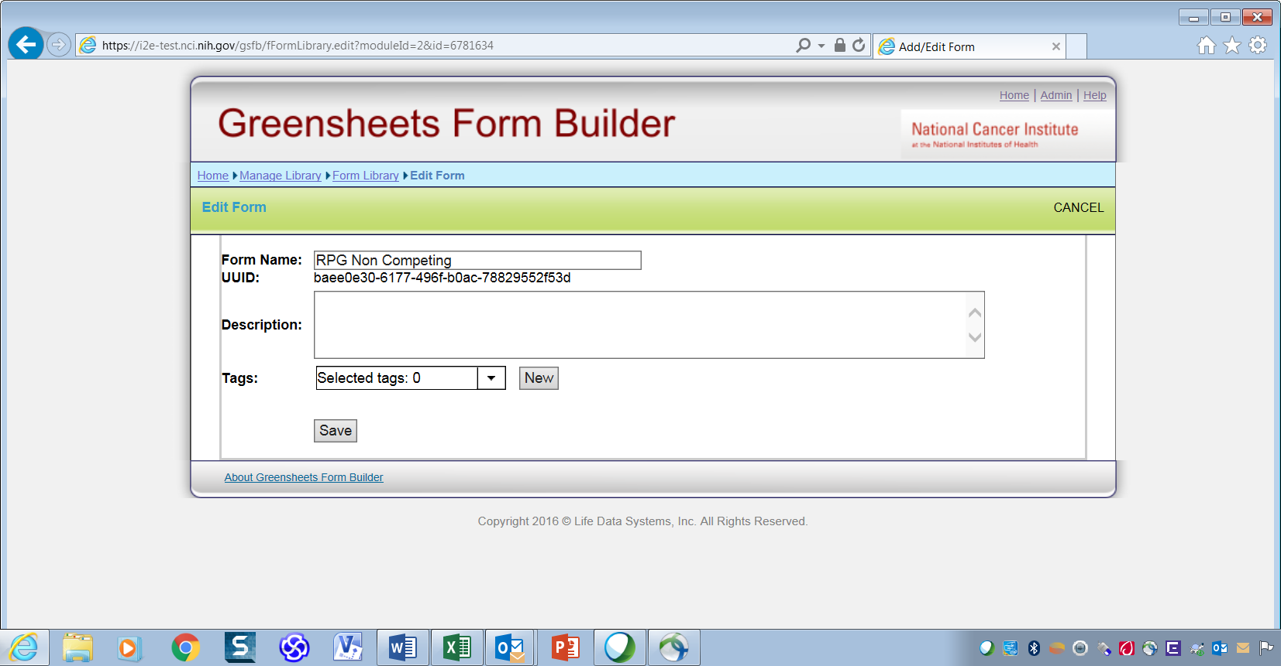

|  |  |  |  |  |
| --- | --- | --- | --- | --- |
| Field name | Length | Message for FB UI | Message in log | Comment |
| Form Name | 2,000 | Form Name cannot be longer than 2,000 characters | Invalid length of Form Name |  |
| Form Description | 2,000 | Form Description cannot be longer than 2,000 characters | Invalid length of Form Description | NOTE: Currently not used in GS; in PostgreSQL => unlimited |
| Tag Name |  |  |  | Not relevant; used by FB only;  Also, we are not sure what tag in in XML (from the question or from the form)? |
| Tag description |  |  |  | Not relevant; used by FB only;  Also, we are not sure what tag in in XML (from the question or from the form)? |
| CreatedBy | 25 bytes | n/a on UI | Invalid length of CreatedBy for the form | NOTE: GS restriction (Oracle) is 30 |
| ModifiedBy | 25 bytes | n/a on UI | Invalid length of modifiedBy for the form | NOTE: GS restriction (Oracle) is 30 |
| uuid | 36 bytes | n/a on UI | Invalid length of uuid for the form | Should it be bytes or characters?  Currently GS restriction (Oracle) is 100 bytes – we need to change it in GS; PostgreSQL => 36 |

### Section Level

Nothing on section level is passed to GS; but users often use ‘description’ field to enter type/mech combos. No requirements to limit any field from GS side

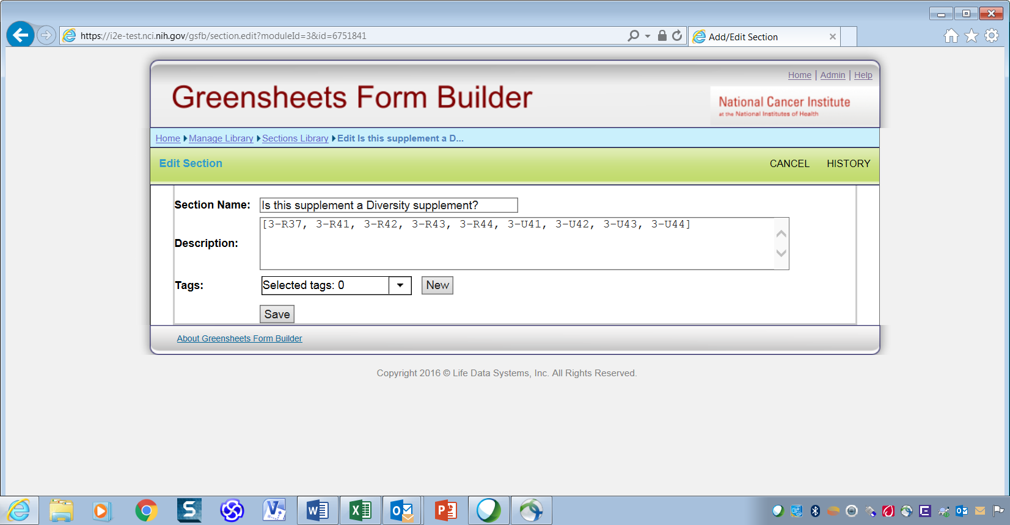

Note: For consistency purposes, it will be good to have UI messages

|  |  |  |  |  |
| --- | --- | --- | --- | --- |
| Field name | Length | Message for FB UI | Message in log | Comment |
| Section Name | 100 | Section Name cannot be longer than 100 characters | n/a |  |
| Description | 2,000 | Section Description is longer than allowed | n/a |  |

### Module Level

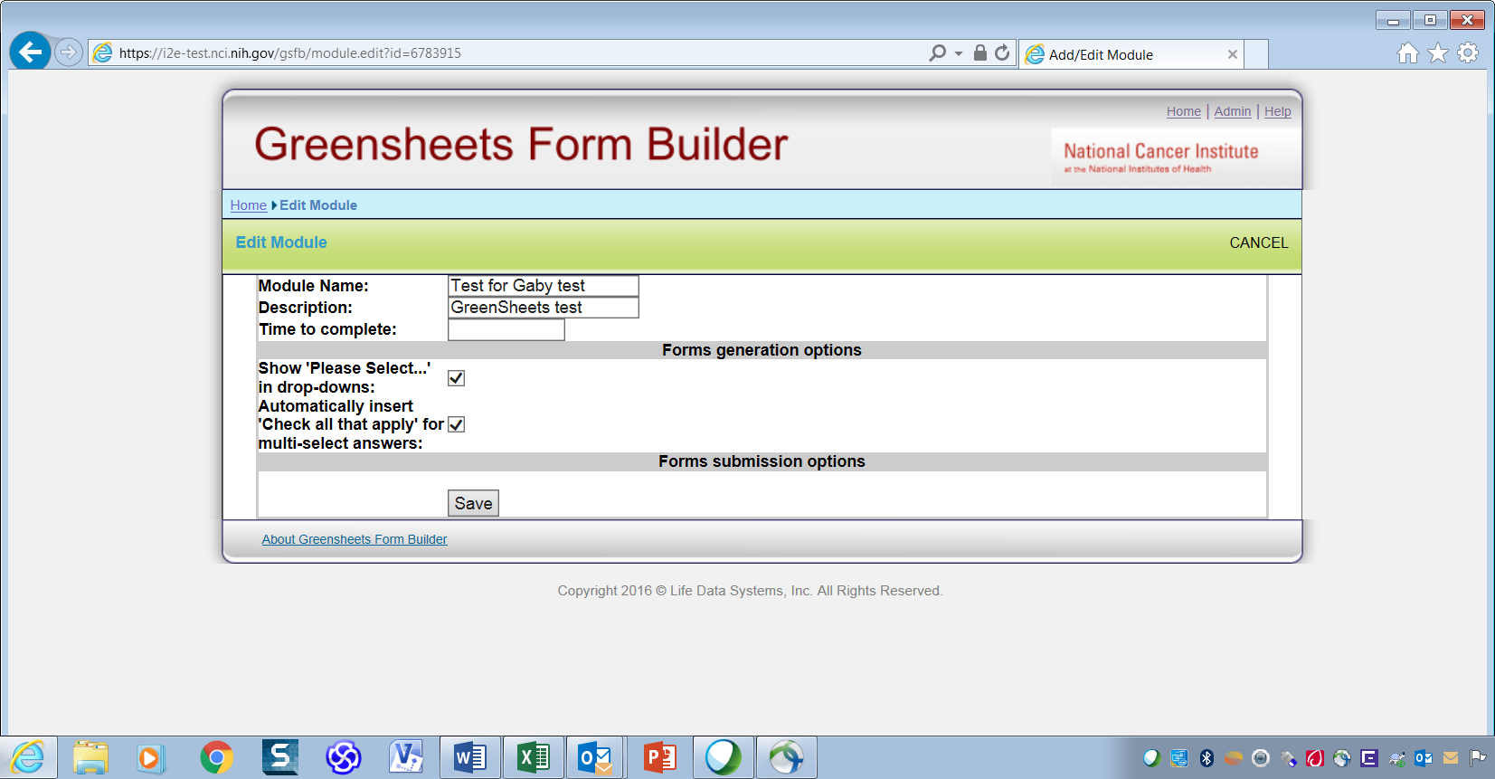

|  |  |  |  |  |
| --- | --- | --- | --- | --- |
| Field name | Length | Message for FB UI | Message in log | Comment |
| Module Name | 100 | Module Name cannot be longer than 100 characters | Invalid length of module name |  |
| Module Description | 200 | Module Description cannot be longer than 500 characters | Invalid length of module description |  |
| Time to complete |  |  |  | Not passes to GS |

### Category Level (related to TypeMech passed to GS)

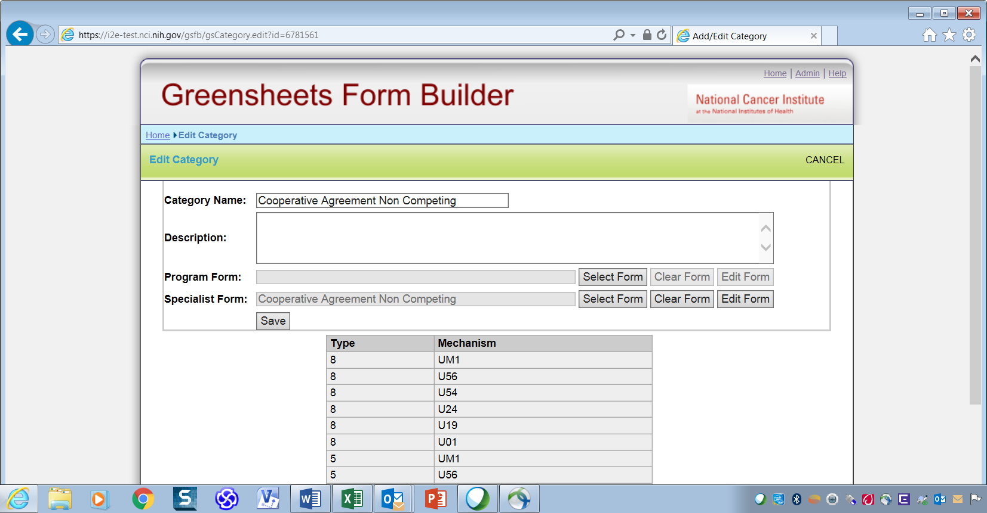

|  |  |  |  |  |
| --- | --- | --- | --- | --- |
| Field name | Length | Message for FB UI | Message in log | Comment |
| Category Name |  |  |  | Not passes to GS |
| Category Description |  |  |  | Not passes to GS |
| grantType | 1 byte | n/a for UI | Invalid length of grantType | Currently in PostgreSQL => 50 |
| grantMechanism | 3 bytes | Mechanism Name cannot be longer than 3 characters (note, it’s applicable only on Edit Mechanism screen) | Invalid length of grantMechanism | Currently in PostgreSQL => 50; Always 3 characters |

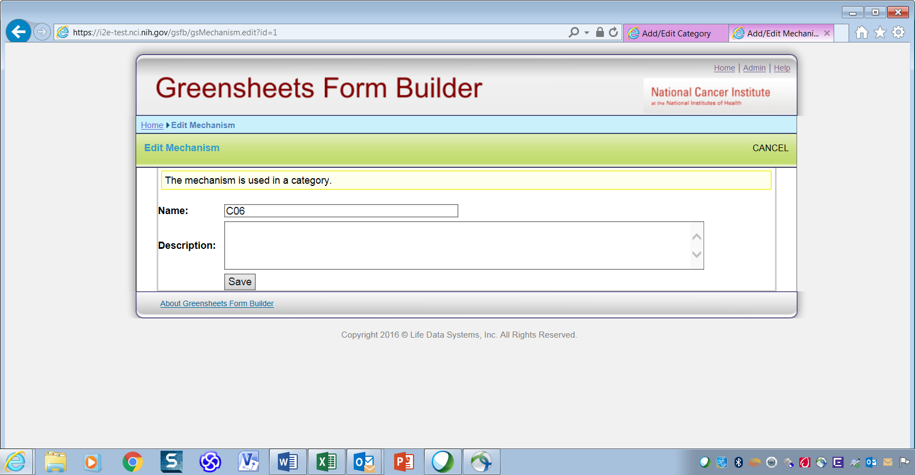

# Issues

Please refer to TBD

|  |  |  |
| --- | --- | --- |
| # | Ticket # | Ticket title |
| 1 | GSFB-112 | Improve the logging of the application |
| 2 | GSFB - 113 | GSFB startup is unacceptable slow (client issue)  Related to Greensheet- 115 ([SCOPE] - Fix FormBuilder timeout) |
|  |  |  |
|  |  |  |